10.83: Doing this problem using kinematics involves four unknowns (six, counting the two angular accelerations), while using energy considerations simplifies the calculations greatly. If the block and the cylinder both have speed v, the pulley has angular velocity v/R and the cylinder has angular velocity v/2R, the total kinetic energy is

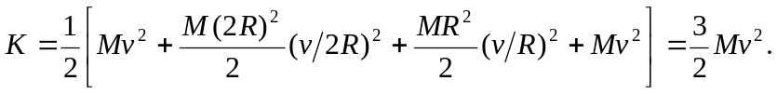
This kinetic energy must be the work done by gravity; if the hanging mass descends a distance y, 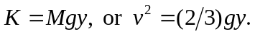 For constant acceleration, 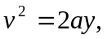 and comparison of the two expressions gives 